Module 3 - PL/SQL Programming
Exercise 1: Control Structures

Creating Tables:

Customers Table:

CREATE TABLE Customers (
CustomerID NUMBER PRIMARY KEY,
Name VARCHAR2(50),
Age NUMBER,
Balance NUMBER,
IsVIP VARCHAR2(5)
);

Loans Table:

CREATE TABLE Loans (
LoanID NUMBER PRIMARY KEY,
CustomerID NUMBER,
InterestRate NUMBER(5,2),
DueDate DATE,
FOREIGN KEY (CustomerID) REFERENCES Customers(CustomerID)
);

Inseting data:

Customers Table:

INSERT INTO Customers VALUES (101, 'Ravi', 65, 15000, 'FALSE');
INSERT INTO Customers VALUES (102, 'Priya', 45, 8000, 'FALSE');
INSERT INTO Customers VALUES (103, 'Amit', 70, 20000, 'FALSE');
INSERT INTO Customers VALUES (104, 'Neha', 30, 5000, 'FALSE');

Loans Table:

INSERT INTO Loans VALUES (201, 101, 8.5, SYSDATE + 15);
INSERT INTO Loans VALUES (202, 102, 9.0, SYSDATE + 45);
INSERT INTO Loans VALUES (203, 103, 7.5, SYSDATE + 20);
INSERT INTO Loans VALUES (204, 104, 8.0, SYSDATE + 10);

COMMIT;

Scenario 1: The bank wants to apply a discount to loan interest rates for customers above 60 years old.
- Question: Write a PL/SQL block that loops through all customers, checks their age, and if they are above 60, apply a 1% discount to their current loan interest rates.

Program Code:
DECLARE
v_age CUSTOMERS.AGE%TYPE;
BEGIN
FOR cust IN (SELECT CustomerID, Age FROM Customers) LOOP
v_age := cust.Age;
IF v_age > 60 THEN
UPDATE Loans
SET InterestRate = InterestRate - 1
WHERE CustomerID = cust.CustomerID;
DBMS_OUTPUT.PUT_LINE(
'1% discount applied for Customer ID: ' ||
cust.CustomerID
);
END IF;
END LOOP;
COMMIT;
END;
/
Output:
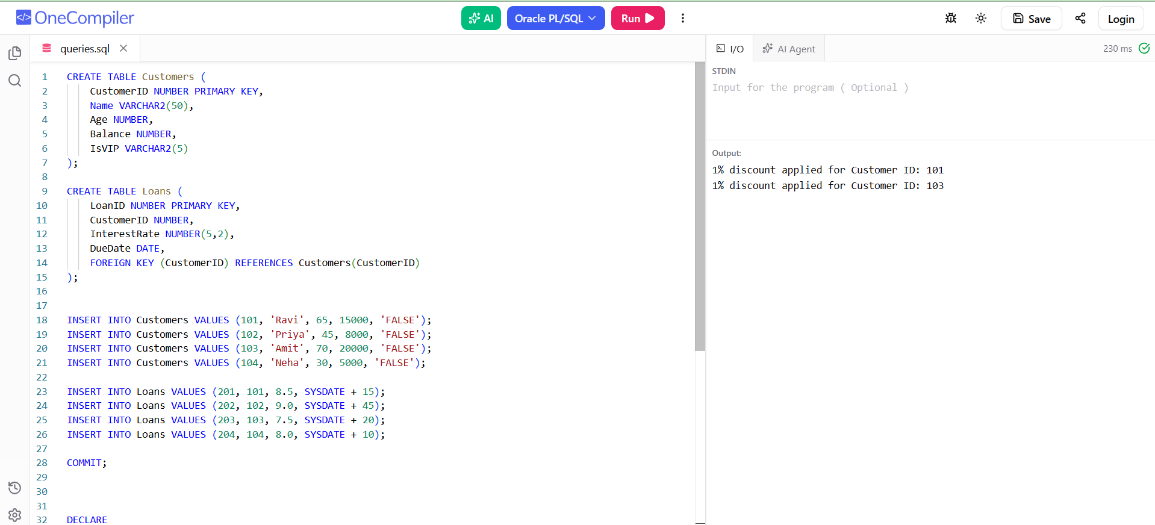

Scenario 2: A customer can be promoted to VIP status based on their balance.
- Question: Write a PL/SQL block that iterates through all customers and sets a flag IsVIP to TRUE for those with a balance over $10,000.
Program Code:
DECLARE
BEGIN
FOR cust IN (
SELECT CustomerID, Balance
FROM Customers
) LOOP
IF cust.Balance > 10000 THEN
UPDATE Customers
SET IsVIP = 'TRUE'
WHERE CustomerID = cust.CustomerID;
DBMS_OUTPUT.PUT_LINE(
'Customer ID ' || cust.CustomerID ||
' promoted to VIP.'
);
END IF;
END LOOP;
COMMIT;
END;
/
Output:
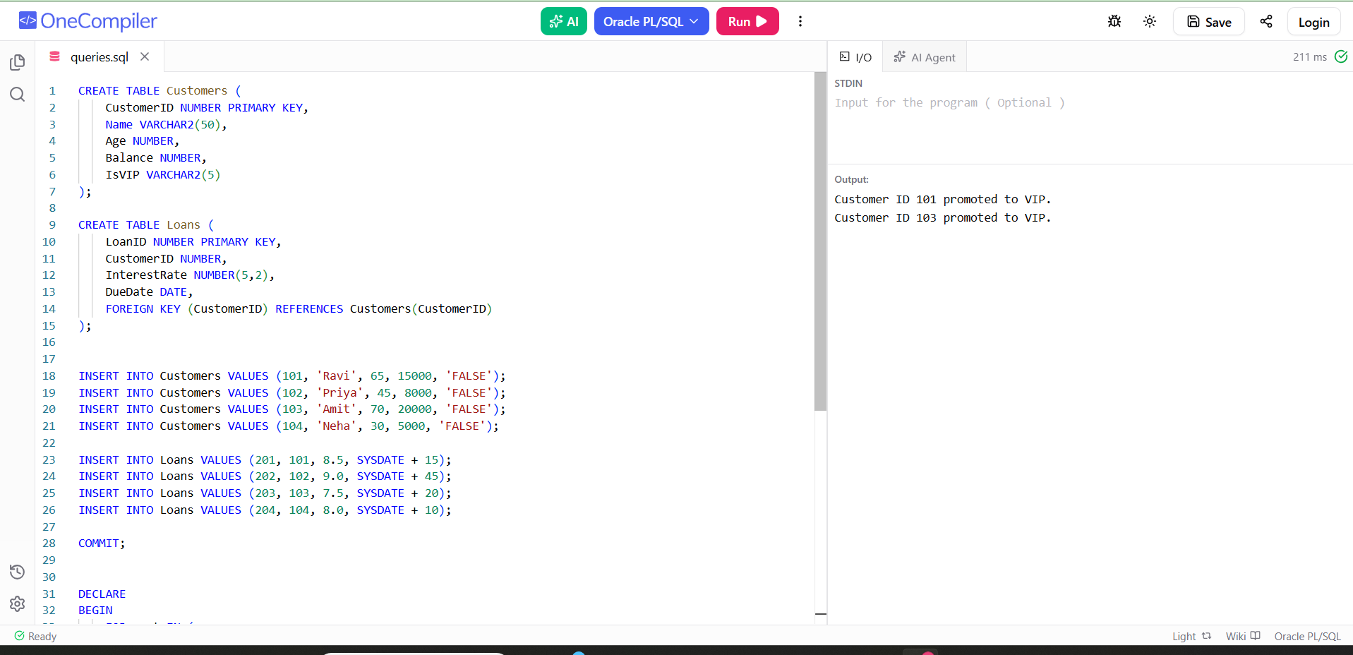

Scenario 3: The bank wants to send reminders to customers whose loans are due within the next 30 days.
  - Question: Write a PL/SQL block that fetches all loans due in the next 30 days and prints a reminder message for each customer.
Program Code:
DECLARE
BEGIN
FOR loan_rec IN (
SELECT c.CustomerID,
c.Name,
l.LoanID,
l.DueDate
FROM Customers c
JOIN Loans l
ON c.CustomerID = l.CustomerID
WHERE l.DueDate BETWEEN SYSDATE AND SYSDATE + 30
) LOOP
DBMS_OUTPUT.PUT_LINE(
'Reminder: Customer ' || loan_rec.Name ||
' (ID: ' || loan_rec.CustomerID || ')' ||
' has Loan ID ' || loan_rec.LoanID ||
' due on ' ||
TO_CHAR(loan_rec.DueDate, 'DD-MON-YYYY')
);
END LOOP;
END;
/
Output:
